Exercise 1. Unit 1

Create an empty virtual machine with Windows 10, 2gb RAM, Boot order, Two hard drives (50 for OS and 30 empy)

Step 1: Select Machine and New one

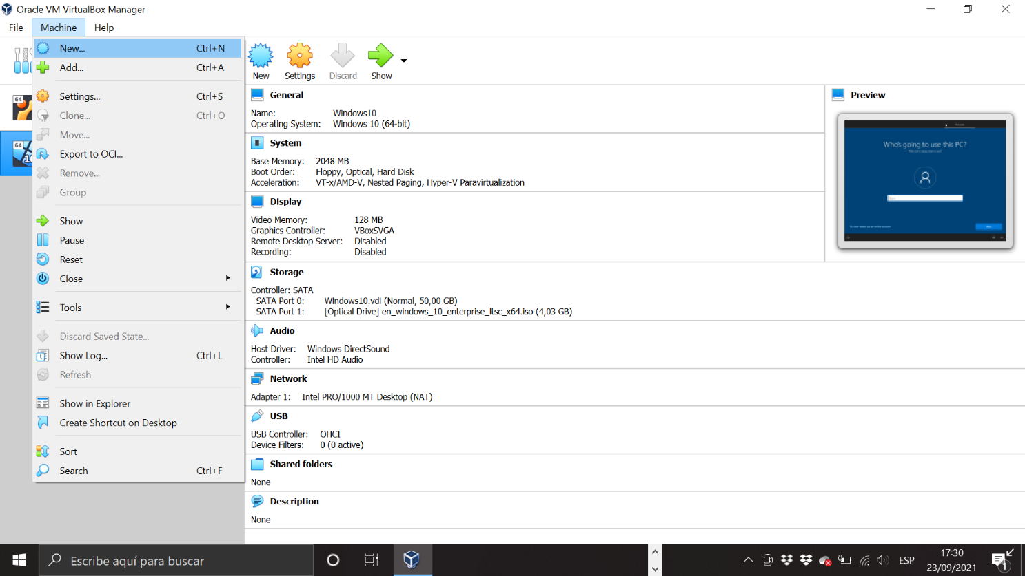

Step 2: We give a name to our new virtual machine: Windows 10.

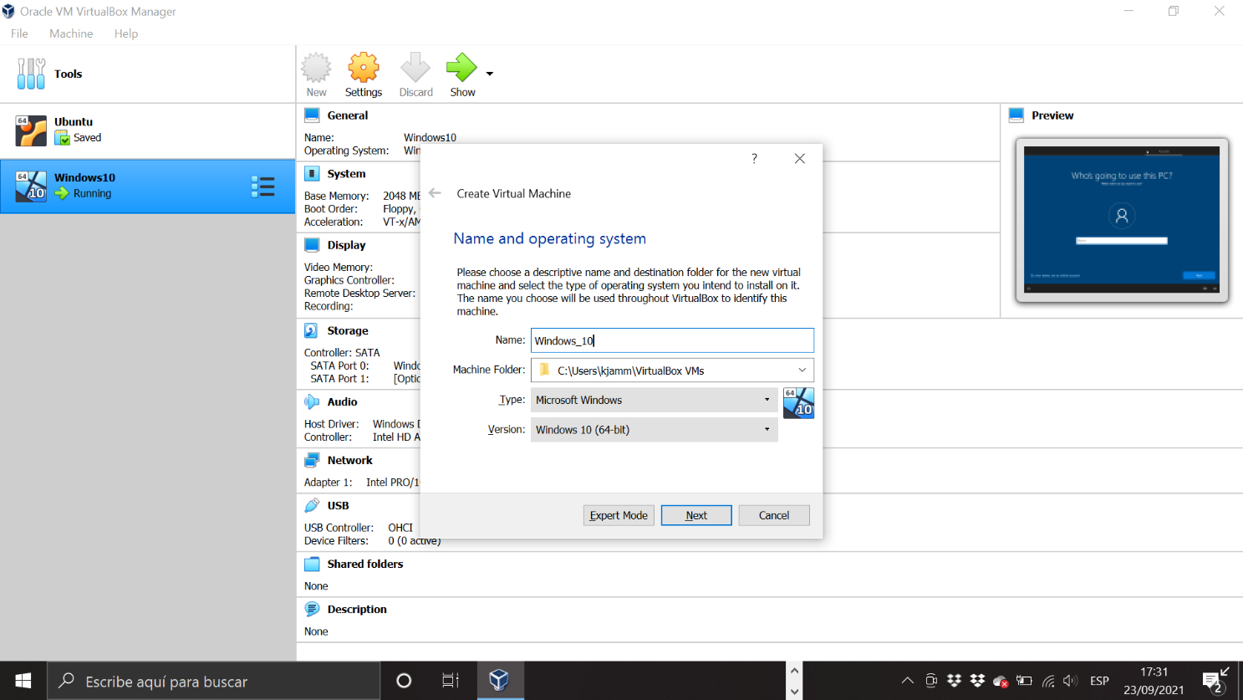

Step 3: We select the RAM`s memory we want it. In this case 2GB.

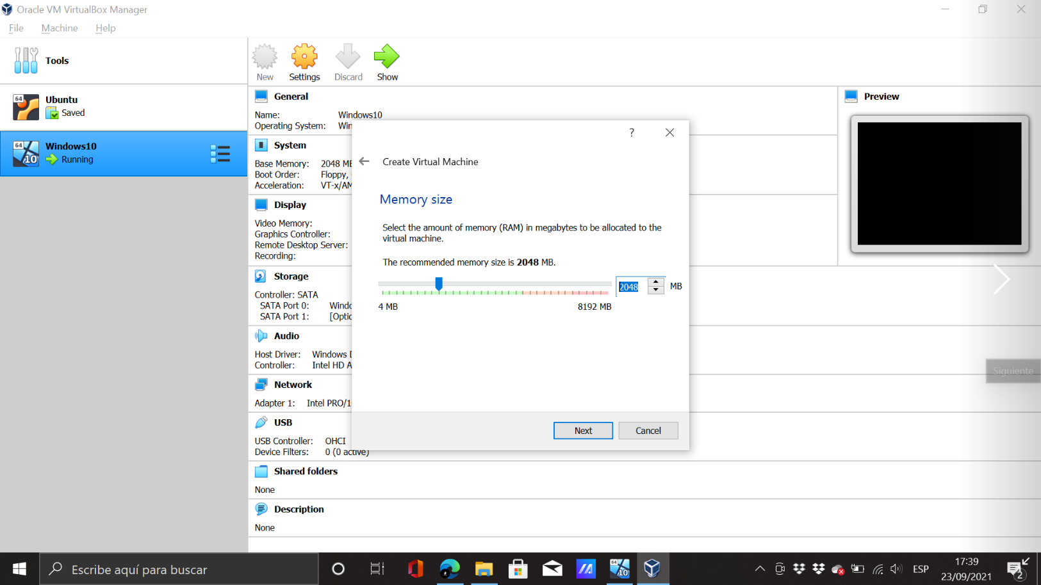

Step 4: We continue with the hard disk selection

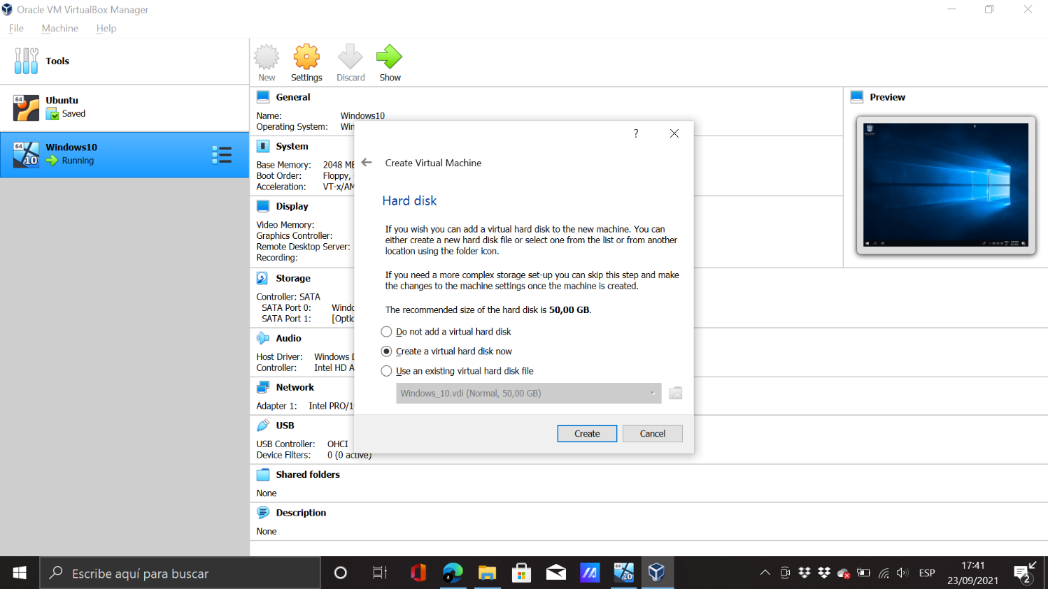

Step 5: We select the file type for the hard disk

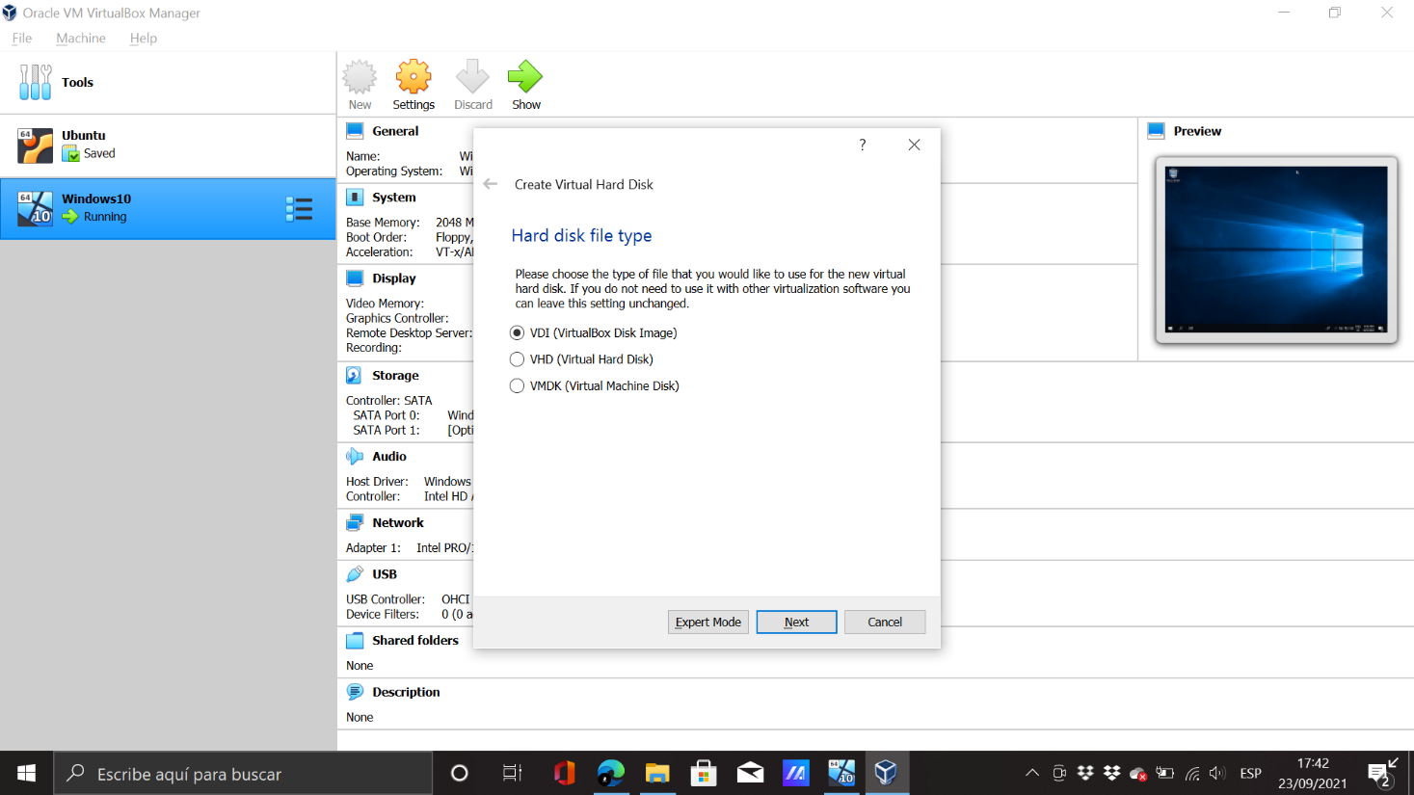

Step 6: We select the type of storage on physical disk

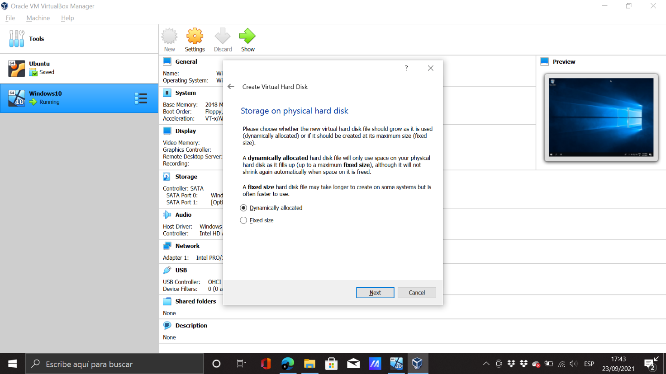

Step 7: We select the storage for our hard disk and we finish the proccess to create our new virtual machine.

